August 15, 2024

Dear ITPA Chapter/Club Secretaries,

Each year, all Clubs and Chapters must submit an Annual Report to their Regional Vice-President. Once an approved annual report is filed with the National Office, the Club/Chapter is eligible to receive a dues refund check. Clubs/Chapters will be reimbursed $6.00 for each member who has paid the current year's dues. Your annual twelve-month reporting period may be the calendar year, your fiscal year, or your election of officer year.
Enclosed with this letter are three (3) documents:

1. Chapter/Club Annual Reporting Form
2. Chapter/Club AZ List
3. RVP Checklist

The completed reports are to be submitted to the respective RVP no later than September 26th, 2024. The RVP is required to submit the Annual Reports and all accompanying forms to the National Office by October 17th, to be eligible for dues reimbursements. Late submissions, incomplete forms, or failure to provide all the requested documents may result in the forfeiture of your Club’s dues refund.

PLEASE KEEP IN MIND THAT YOU MUST INCLUDE COPIES OF ALL OF THE FOLLOWING FOR A DUES REFUND:
• MEETING MINUTES FROM ANNUAL MEETING
• CURRENT LIST OF OFFICERS, INCLUDING ITPA MEMBERSHIP NUMBERS (located on
the A-Z membership list) *ALL OFFICERS MUST BE ACTIVE MEMBERS OF THE ITPA*
• SERVICE PROJECT(S) AND DESCRIPTION(S) - AT LEAST ONE IS REQUIRED PER YEAR
• CORRECTED/UPDATED AZ LIST (see note below)
NOTE: You may return your UPDATED AZ list directly to the National Office via email for processing. Please be sure to indicate this on your RVP Checklist form to avoid any delays in processing your forms. The membership database will be updated according to the information you provide on the updated AZ List. Please ensure it is accurate and legible with all changes HIGHLIGHTED.

Dues reimbursements will be processed after all the completed Chapter/Club Annual Reporting forms and updated AZ Lists have been returned to the National Office. Refund checks are typically mailed to the Club Treasurer in November. Accurate address information must be provided for your Club Officers. Completion of the Annual Report is required, to be eligible to participate in the National Awards Program.

Should you have any questions or concerns, please contact Andrea Wick at the National Office by email, or at the address and telephone number listed below. You may also contact your RVP. Thank you for being a part of the ITPA!

Yours in Pioneering,
Andrea Wick
Executive Director, ITPA
Main Line: 912-408-4872
itpa@telecom-pioneers.net

Independent Telecommunications Pioneer Association Annual Report Form

The updated AZ list has been submitted directly to the National Office via email for processing:
YES or NO
(If no is indicated above, you must include a printed copy of your updated AZ list in this packet)
Our Chapter/Club has met the minimum requirements and is eligible for a dues reimbursement. We also understand that all requested attachments be provided with this report and an updated AZ List & Officer List submitted. Reports must be mailed or emailed to the Regional Vice President and postmarked no later than September 26th.
Submitted By: Email Address: Office Held: Phone:
Date:

Regional Vice President Coverage Information

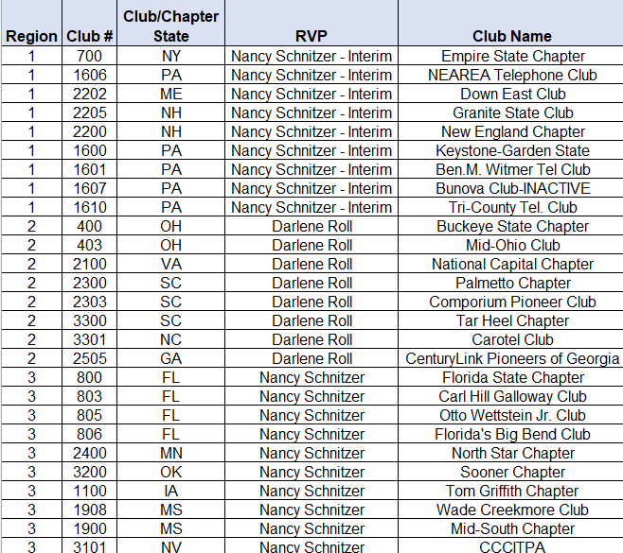

Independent Telecommunications Pioneer Association Club and Chapter Annual Report Checklist
To be Completed by the Regional Vice President Only (Clubs/Chapters do not write in this space)

Club/Chapter Name: Club/Chapter Number:
RVPs - please initial next to each completed item:
Annual Report Forms
Date of Election of Officers with Contact Information
Annual Business Meeting Held (at least 1 per year)
Minutes from the Annual Business Meeting
Service Project and Description (at least 1 per year)
Updated/Corrected AZ List attached (if not emailed directly to National Office)
I do hereby certify that the enclosed Annual Report is:
Complete & Approved Incomplete
(indicate missing items in the comment section)

Comments:
Regional Vice President Signature Date

Independent Telecommunications Pioneer Association Club and Chapter Annual Report Form
Chapter/Club Name: ____________________________________ Chapter/Club Number: ________________
ITPA National Office 438 W. Oglethorpe Hwy Hinesville, GA 31313
912-408-4872
Email: itpa@telecom-pioneers.net
___________________

Independent Telecommunications Pioneer Association Club and Chapter Annual Report Form
Chapter/Club Name: Chapter/Club Number:

President  Name: ITPA Membership # Address:  E-mail Address:  Day Phone: Evening Phone: | Title  Mr. Ms. Mrs.  Miss Dr. Address Type Business Residence
Vice President  Name: ITPA Membership # Address:  E-mail Address:  Day Phone: Evening Phone: | Title  Mr. Ms. Mrs.  Miss Dr. Address Type Business Residence
Secretary  Name: ITPA Membership # Address:  E-mail Address:  Day Phone: Evening Phone: | Title  Mr. Ms. Mrs.  Miss Dr. Address Type Business Residence
Treasurer  Name: ITPA Membership # Address:  E-mail Address:  Day Phone:  Evening Phone: | Title  Mr. Ms. Mrs.  Miss Dr. Address Type Business Residence | _

Chapter/Club Mailing Address:

Does your Club/Chapter have a social media account? If yes, please list which social media platform(s) are being used, and the name of the Club as listed as so that we can connect with you:

Election of Officers
Date of Election (MM/DD/YY): Terms of Office (MM/DD/YY): Annual Reporting Dates (MM/DD/YY):
Which officer should the dues reimbursement check be mailed to?
Annual Business Meeting (may be held by teleconference or by electronic mail)
Date of Annual Business Meeting (MM/DD/YY): Copy of Minutes from Annual Business Meeting Attached: Yes No
Service Project
Date of Service Project (MM/DD/YY): Description of Service Event:

ITPA National Office 438 W. Oglethorpe Hwy Hinesville, GA 31313
912-408-4872
Email: itpa@telecom-pioneers.net

